LAB 11

1.

package com.company;  
  
import java.util.\*;  
import java.io.File;  
import java.io.IOException;  
  
public class fiostream{  
 public static void main(String[] args) throws IOException{  
 Scanner in = new Scanner(System.*in*);  
 File f1 = new File("JAVA");  
 File f2 = new File("JAVA/abc.txt");  
 f1.mkdir();  
 f2.createNewFile();  
 System.*out*.println("file and folder is created ");  
 if(f2.exists()){  
 System.*out*.println("the file exists !");  
 }  
 else{  
 System.*out*.println("file does not exists !");  
 }  
 if(f2.isDirectory()){  
 System.*out*.println("file present inside Directory !");  
 }  
 else {  
 System.*out*.println("not in Directory :(");  
 }  
 if(f2.isFile()){  
 System.*out*.println("is a file !");  
 }  
 else{  
 System.*out*.println("not a file");  
 }  
 String str = f2.getName();  
 if(f2.exists()){  
 System.*out*.println("the file name is : " + str);  
 }  
  
 }  
}

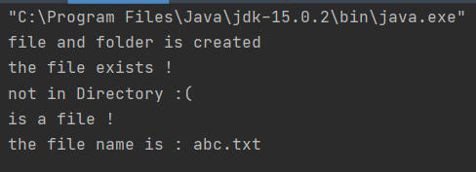

2.

package com.company;  
import java.io.\*;  
public class fiostream {  
  
 public static void main(String[] args) {  
 try {  
 File file1 = new File("initial.txt");  
 File file2 = new File("final.txt");  
 char CharCounter = 0;  
 BufferedReader in = (new BufferedReader(new FileReader(file1)));  
 PrintWriter out = (new PrintWriter(new FileWriter(file2)));  
 int ch;  
 while ((ch = in.read()) != -1)  
 {  
 if (Character.*isLowerCase*(ch))  
 {  
 ch=Character.*toUpperCase*(ch);  
 }  
 out.write(ch);  
 }  
 in.close();  
 out.close();  
 }  
 catch (Exception e) {  
 System.*out*.println("An error occurred.");  
 }  
 }  
}

Initial.txt



Final.txt



3.

package com.company;  
import java.util.Scanner;  
import java.io.\*;  
  
public class DataEntry  
{  
 public static void main(String[] args) throws IOException  
 {  
// kb input  
 Scanner kb = new Scanner(System.*in*);  
  
// file output  
 PrintWriter fileout = new PrintWriter(new File("data.dat"));  
  
// input item number and quantity until "stop" is entered  
 String next;  
  
 System.*out*.print("Enter item number or \"stop\" to exit: ");  
  
 while(kb.hasNext())  
 {  
 next = kb.next();  
  
 if(next.equals("stop"))  
 {  
 break;  
 }  
  
 int itemNum = Integer.*parseInt*(next);  
  
 System.*out*.print("Enter the quantity: ");  
 int quantity = kb.nextInt();  
  
// output item number and quantity to file  
 fileout.println(itemNum+"\t"+quantity);  
 }  
  
// save file  
 fileout.close();  
 }  
}

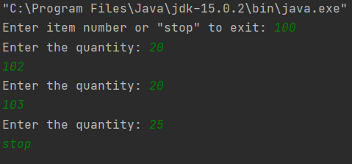

4.

package com.company;  
import java.io.FileInputStream;  
import java.io.FileOutputStream;  
import java.io.ObjectInputStream;  
import java.io.ObjectOutputStream;  
import java.io.Serializable;  
import java.util.Scanner;  
  
class data implements Serializable {  
  
 int itno;  
 float price;  
  
 public data(int itno, float price) {  
 this.itno = itno;  
 this.price = price;  
 }  
}  
  
class fiostream {  
 public static void main(String[] args) throws Exception{  
  
 Scanner in= new Scanner(System.*in*);  
 System.*out*.println("Enter no. of data-sets: ");  
 int n= in.nextInt();  
 int itno;  
 float price;  
 int length;  
  
 FileOutputStream fileOut = new FileOutputStream("file.txt");  
 ObjectOutputStream objOut = new ObjectOutputStream(fileOut);  
 try {  
 for (int i=0; i<n; i++){  
 System.*out*.println("Data "+(i+1)+"\nItem no: ");  
 itno=in.nextInt();  
 System.*out*.println("Price: ");  
 price=in.nextFloat();  
 length = (int) (Math.*log10*(itno) + 1);  
 if(length !=3){  
 throw new Exception();  
 }  
 data d = new data(itno, price);  
 objOut.writeObject(d);  
  
 }  
 objOut.close();  
 }  
  
 catch (Exception e) {  
 System.*out*.println("Please enter valid input");  
 }  
 }  
}

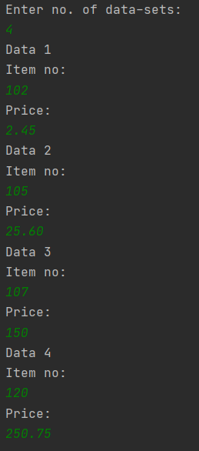

5.

package com.company;  
import java.io.FileInputStream;  
import java.io.FileOutputStream;  
import java.io.ObjectInputStream;  
import java.io.ObjectOutputStream;  
import java.io.Serializable;  
import java.util.Scanner;  
  
class data implements Serializable {  
  
 int itno;  
 float price;  
  
 public data(int itno, float price) {  
 this.itno = itno;  
 this.price = price;  
 }  
}  
  
class fiostream {  
 public static void main(String[] args) throws Exception{  
  
 Scanner in= new Scanner(System.*in*);  
 System.*out*.println("Enter no. of data-sets: ");  
 int n= in.nextInt();  
 int itno;  
 float price;  
 float total=0;  
 int length;  
  
 FileOutputStream fileOut = new FileOutputStream("file.txt");  
 ObjectOutputStream objOut = new ObjectOutputStream(fileOut);  
 FileInputStream fileIn = new FileInputStream("file.txt");  
 ObjectInputStream objIn = new ObjectInputStream(fileIn);  
 try {  
 for (int i=0; i<n; i++){  
 System.*out*.println("Data "+(i+1)+"\nItem no: ");  
 itno=in.nextInt();  
 System.*out*.println("Price: ");  
 price=in.nextFloat();  
 length = (int) (Math.*log10*(itno) + 1);  
 if(length !=3){  
 throw new Exception();  
 }  
 data d = new data(itno, price);  
 objOut.writeObject(d);  
  
 data newdata = (data) objIn.readObject();  
 System.*out*.println("Item no: " + newdata.itno);  
 System.*out*.println("Price: " + newdata.price);  
 total=+newdata.price;  
  
  
 }  
 System.*out*.println("Total Price: "+total);  
 objOut.close();  
 objIn.close();  
  
 // Reads the objects  
  
  
  
  
  
 }  
  
 catch (Exception e) {  
 System.*out*.println("Please enter valid input");  
 }  
 }  
}

